Speak Your Truth
The Poetry Lounge
Hosted by Ger Duffy
Saturday 25th April 2-4pm
Martin Malone , Gardenstown.
Moderated by Frank Farrelly
Kelly Michels, American Anthem.
Moderated by Ger Duffy
Lauren O’ Donovan, Taxidermy Heart.
Moderated by Joanne Mc Carthy
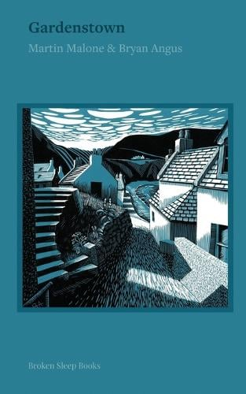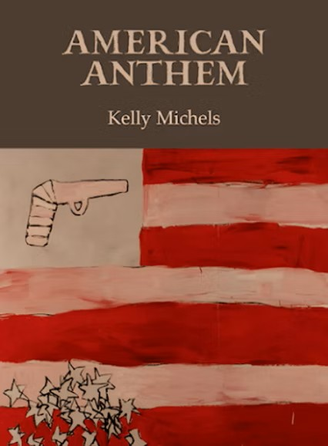
Waterford Gallery of Art, O’Connell Street, Waterford Free event. 