Speak Your Truth
invite you to a generative Poetry Workshop
with Martin Malone.
Martin has published four poetry collections and five pamphlets. He is an editor at Poetry Salzburg Review and was Poetry Ambassador for the Scottish Poetry Library.

on Saturday 25th April
10.30 - 12.30
in the Waterford Gallery of Art
O’ Connell Street, Waterford.
Cost of the workshop is €25
To book a place email; sytwritersworkshops@gmail.com Places are limited to 12, once you express your interest, payment details will be sent to you.
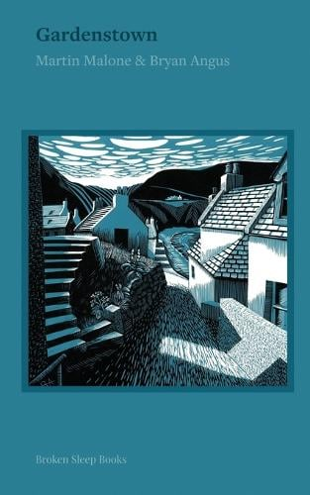 Martin’s Latest book, Published by Broken Sleep Books 